Bridgend

1. Bot will enter the link in Search Engine [**http://planning.bridgend.gov.uk/**](http://planning.bridgend.gov.uk/)

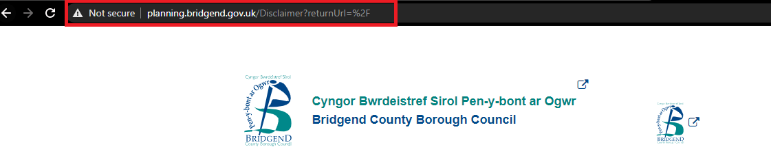

1. Bot will Click **“Agree”** for Ts & C’s

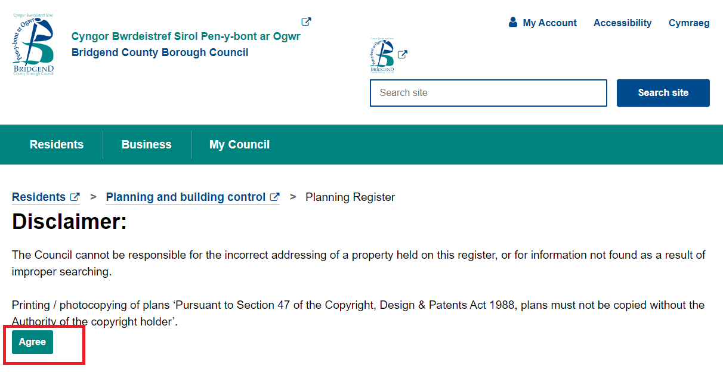

1. In **“Application Location”** field, Bot will enter first line of address **(house number/name and street)** & Click **search**

**Note:** We didn’t get an site address to search, so we given bot an keyword “Bridgend” to enter in Application location

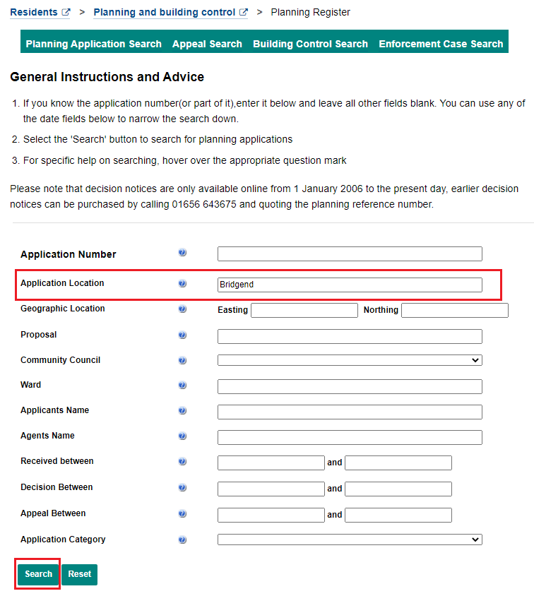

1. Multiple Results has shown for the keyword we searched, Now Bot will click on application number (left of screen) for full application information.

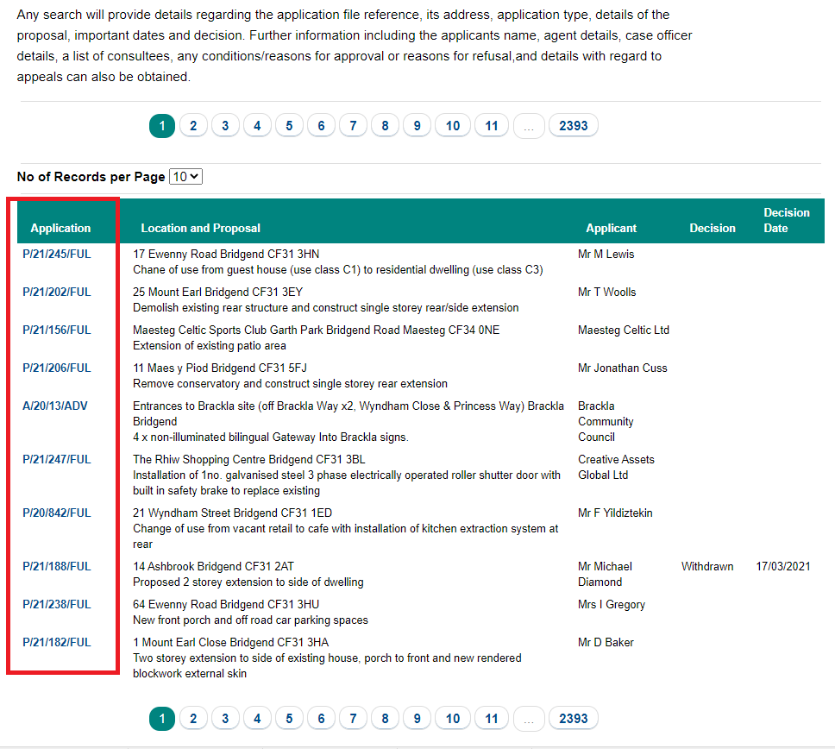

1. The application details will show which are slightly differ compare to other websites

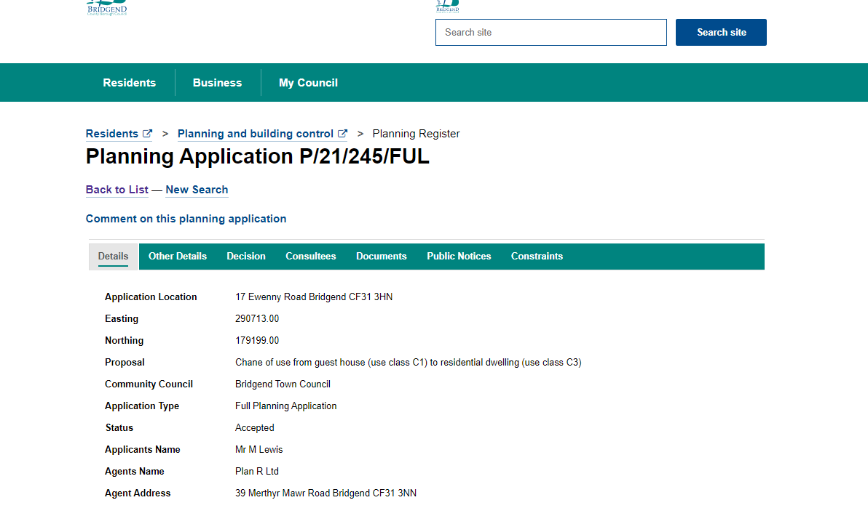

1. So the bot has extracted every fields in the details tab

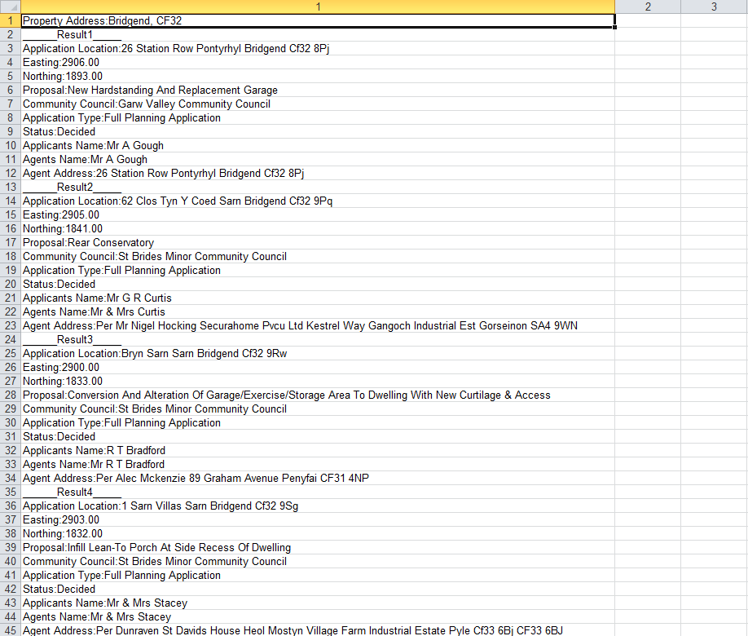

## Questions:

1. What are the fields that the bot need to extract from the planning application or is it good to extract all fields in the “details” tab?

Responses:

1. Essential fields to be extracted for this LA:

“Details Tab”

Application Location

Proposal

Application Type

Status

“Decision Tab”

Decision

Decision Date

Again, spacing of applications on excel sheet could be better.